Monthly Performance Report – September 2026
Kestrel Ridge Wind Farm (75.6 MW)
David Chen · 02 October 2026 · KR-OPS-RPT-2026-09

1. Summary
Kestrel Ridge generated 15.0 GWh in September 2026, 0.7 % above the P50 budget of 14.9 GWh. Availability of 97.4 % met the contract target of 97.0 %. Mean hub-height wind speed of 7.5 m/s was close to the long-term mean (7.6 m/s). Compared with September 2025 (15.2 GWh), output was down 0.2 GWh.
Annual service campaign 2026 completed on 25 September – all 18 turbines serviced, three weeks earlier than in 2025.

Winter readiness checks (ice detection, heated anemometers, warning beacons) started on 28 September.

2. Production and key figures
KPI | September 2026 | Budget / target | YTD 2026 | YTD budget
Net generation (GWh) | 15.0 | 14.9 | 144.6 | 148.5
Time-based availability | 97.4 % | 97.0 % | 97.0 % | 97.0 %
Capacity factor | 27.6 % | 27.4 % | 29.2 % | –
Mean wind speed at hub height (m/s) | 7.5 | 7.6 | – | –
Source: Kestrel Ridge SCADA, revenue meter at 132 kV point of connection. Budget = P50 (2024 post-construction yield assessment).
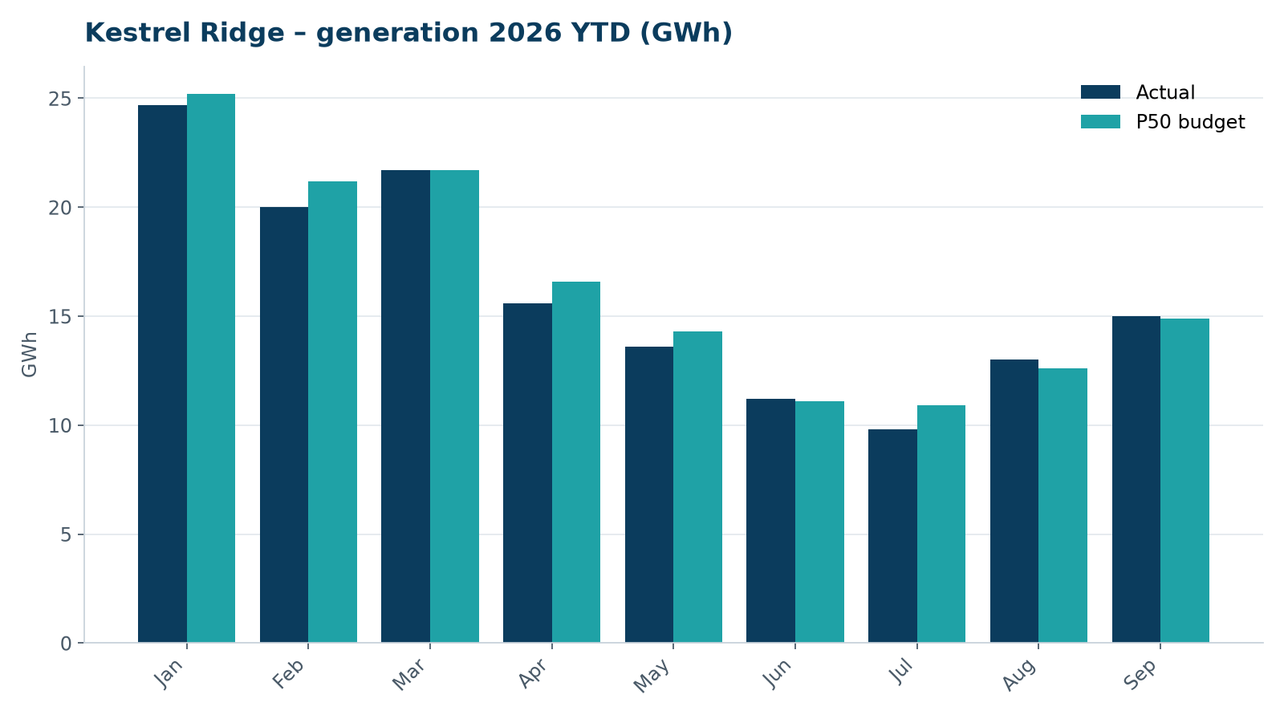
Monthly generation vs. P50 budget, 2026 year to date

3. Availability and downtime
Total turbine downtime attributable to the contractor amounted to 44 turbine-hours for the top events listed below. No grid or force majeure exclusions were claimed this month.
Turbine | Event | Downtime (h)
T-05 | pitch motor encoder fault on blade B | 23
T-13 | pitch system fault – accumulator pressure low on blade C | 10
T-12 | high-voltage transformer gas relay alarm (inspected, no fault found) | 9
T-11 | main shaft temperature sensor fault | 2
Top downtime events of the month (SCADA event log, reviewed with Highline Wind Services).

4. Maintenance
- Annual service: 2 turbines completed this month.
- 11 corrective work orders closed, 6 still open at month end.
- Site access track inspected; two drainage culverts cleared after heavy rain.

5. Health, safety and environment
Indicator | Month
Hours worked on site (Highline + Weyland) | 4,015
Lost time injuries | 0
First aid cases | 0
Near misses reported | 2
Safety observations | 4
Environmental incidents | 0

No complaints from neighbours were received this month.

6. Outlook
The P50 budget for next month assumes normal seasonal wind; no planned outages beyond routine maintenance.
Prepared by Sara Lindgren (Performance Analyst); reviewed by Ben Okoye (Site Manager) and David Chen (Asset Operations Manager).

